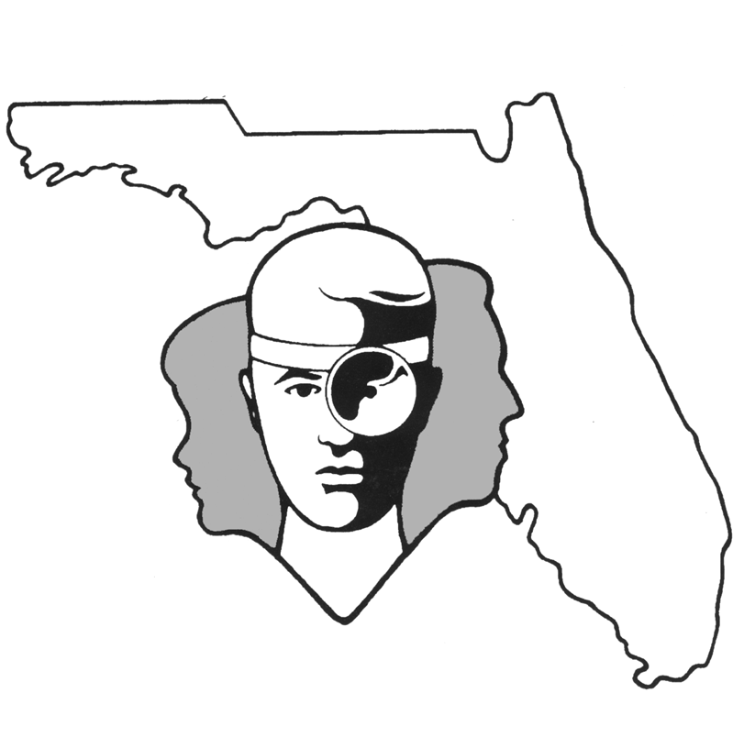
TALLAHASSEE EAR, NOSE & THROAT - HEAD & NECK SURGERY, P.A.

www.TallyENT.com Office Phone: 850-877-0101

PATIENT DISCHARGE INSTRUCTIONS: (MICRO) LARYNGOSCOPY with or without a BIOPSY

POST-ANESTHETIC CONSIDERATIONS: Anesthetics and other medications will be in your body 24 hours, so you may feel a little sleepy. This feeling will slowly wear off, but for the next 24 hours, adults should not:
- Drive a car, operate machinery or power tools ● Drink any alcoholic beverages
- Take any medication except as directed ● Make any important decisions – such as signing legal documents
Certain anesthetics and pain medications may produce nausea & vomiting which usually resolves by the evening of the surgery.

ACTIVITY & VOICE USE: You can gradually increase activity to normal levels beginning 24 hours after the procedure. If you had a more extensive procedure, use common sense in terms of the amount of activity you do. Limit voice use as much as possible and avoid throat clearing for 2 weeks. Your doctor will advise you on voice rest. When you must talk, do so softly. Do not sing, shout or strain your voice. DO NOT WHISPER.

DIET: Progress slowly to a regular diet as tolerated. It is very important to stay well hydrated. It is better to start with liquids such as apple juice, Ginger Ale, or Gatorade, then soup, and gradually solid foods. Remember that some beverages may "burn" when swallowed. This is especially true of carbonated drinks or citrus juices. Popsicles and ice-cream are fine to try.

MEDICATIONS: Use only Tylenol or other pain medication prescribed by your surgeon. You may take anti-inflammatory medications (these include Motrin, Advil, Ibuprofen, etc.) if your doctor instructs you to, but avoid aspirin. This is very important as some of these medications can cause bleeding. You may use a vaporizer or try throat lozenges to soothe your throat if necessary. Smoking should be avoided.

SYMPTOMS TO EXPECT: You can expect a moderate sore throat the first night. This should improve each day. There may be a mild fever, but generally not above 101.0 degrees after the first night. There may be a mild bit of blood-tinged mucus during the first night, but this generally resolves after 12 hours. Expect drowsiness from the pain medications. Your voice may still be hoarse as it heals.

WHEN TO CALL YOUR PHYSICIAN:
- If you have a temperature over 101.5 degrees or have the chills
- If you are unable to drink fluids, have difficulty swallowing or breathing
- If there is more than ½ cup of bleeding; If the bleeding is severe, go immediately to the emergency room and contact the physician from there
- Pain uncontrolled by the prescribed pain medication or over the counter medications
- Excessive vomiting

SPECIAL INSTRUCTIONS: A postoperative appointment has already been scheduled. Please refer to your Surgery Information Sheet or call the office to confirm the appointment date and time. We strongly suggest that a responsible adult be with the surgical patient the rest of the day and also during the night for the surgical patient's protection and safety. Please contact your physician immediately if you have an emergent situation. If you find that you cannot contact them, but feel that your signs and symptoms warrant a physician's attention, go to the nearest emergency room. For non-emergent questions (i.e. appointments or general questions), please call during normal office hours.

